 | MINISTRY OF EDUCATION AND TRAINING

FPT UNIVERSITY
Capstone Project Document
Gas selling support system

Report 3: Software Requirement Specification (SRS)
GSS Team
Group Member | Nguyễn Xuân Quyết 00818  Nguyễn Đức Vượng 01067  Đinh Nho Hào 00985  Nguyễn Huy Tuấn 00986  Lê Thế Đại Dương 01098
Supervisor | Mr. Phan Duy Hùng
Capstone Project code | GSS_v1.0

- Hanoi, May 19th 2012 -

The Table of Contents

1. User Requirement Specification 3
1.1. Purpose of system 3
1.2. Scope 3
1.3. Definitions, acronyms and abbreviation 3
1.4. User characteristics 4
1.5. Functional requirement 4
1.6. System attributes 7
Reliability 7
Availability 8
Security 8
Maintainability 8
Portability 9
Performance 9
2. System Requirement Specification 9
2.1. System feature 9
2.2. External Interface Requirements 16
3. Entity relationship diagram 19

User Requirement Specification

Purpose of system
This project is registered and implemented as a capstone project for the team members. Our purpose is to fulfill the requirements from FPT University studying program.

Scope
The system of which this document concerns is a Gas selling support system. The system will be contained software that will be installed on and reside in the computers of a gas selling system to improve customer services. In addition, the system will be contained hardware which will be connected with telephone to decode telephone number of customers and send to the PC.
When our hardware connect with telephone, although any type of call from customers (DTMF or FSK type) or miscall, it will decode and log, then, it will transmit phone number to computer by RS232. When our software receives phone number, it will be evaluate known data and use it to support for seller. The system will be improved the quality of customer services by providing information of customers, products and business activities of shop.

Definitions, acronyms and abbreviation
Acronym | Definition | Note
SRS | Software Requirement Specification
GSS | Gas Selling support System
DTMF | Dual Tone Multi Frequency | A type of signal telephone
FSK | Frequency-Shift Keying | A type of signal telephone

User characteristics
Our system concern to three objects: customer, manager and staff.
Customers: the persons are not directly using our system but they have effect with our system. Our system will be stored information of customer, detect and log phone number whenever they call. From phone number, our system will provide information of customer, product… Whereby manages can improve customer services and quality of business activities.
Managers: the persons who mainly use our system. They manage information of database. Our system will collect, summarize and show information customer for them. With this information, they will increase effective and improve customer services. In additions, our system also helps managers to manager information of products, store, profit, turnover, discount, promotion…
Staff: Our system will be stored information of staff and support to assign task for each staff. Moreover, our system has some functions to support for staff such as: find shortest path, create bills…

Functional requirement
Embedded
Connect with telephone
Our circuit has 3 parts: receive signal (SM8223A), microprocessor (16F876A) and transmit signal to computer (RS232). It will connect directly with telephone cable and other cable connects with computer by USB port. This connecting ensures that phone number of customer will transmit to computer quickly and accurately.
Decode incoming telephone number of customer
After receiving signal from telephone, signal will transmit to SM8223A, here, it is processed and decoded, then pass to microprocessor 16F876A. The result of processing and decoding are telephone number, distinguish from DTMF signal or FSK signal and miscall or not before data is transmitted to computer through RS232.
Transmit phone number to computer
Our circuit is connected with computer by RS232 and a cable which is pitched computer in USB port. Processed and decoded data will be transmitted whole to computer. From call come in to data is transmitted to computer which takes 3- 5seconds.

Software
Display information of customer by telephone number
When call of customer comes in, after 3-5 seconds, hardware will detect phone number and transmit to software. Software will find information in the database by phone number. Information will be displayed include: name, address, map, debt (if have), information of products, note…. If this is the first time they call to shop, software will allow new screen to enter information into database.

Log miscalls
When customers call in the shop but nobody answer the phone, system will log accurately call time, number phone and name customer (if have). These calls will be put in miscall category and displayed on main screen.

Statistic and calculate purchasing circle
With customers who bought gas 3 times or more, system will statistic and calculate purchasing circle automatically. The first start system of the day, the system will show user to know customer who would buy gas in next days.

Print bill with map
System will be connect with printer and allow user print bill for customer. With information such as: name, address, products, price…. In bill, there is a map to address of customer. This will support employee to find way and quickly deliver products.

Find shortest path
Through address which is provided by customers, just computer is connected with internet, system will automatically find shortest path from shop to address of customer. This map will be printed and given to delivery employees. This function will save time to deliver product and improve customer services.

Manage information of customers
This function has 4 actions: Insert, delete, update and search customers
+) Insert customer: When a new customer call in to shop, insert screen will be display. Staff will enter some information such as: Name, add, phone number, products, price of products, debt (if have)… A customer can have many phone numbers but a phone number there is only one customer.
+) Delete customers: When manager read information of customers, they can press Delete button. Before deleting record in database, the system will display confirming screen.
+) Update customers: Managers can change information of customer but cannot change phone number. Updating can perform when customer call in or later.
+) Search customers: On the screen, there is a text search. Manager can search information of customers by phone number, name.

Manage information of products
This function has 4 actions: Insert, delete, update and search products
+) Insert products: System allow user to insert more products into database by pressing insert products button. In insert product screen, user can enter name, bran, type, quantity and price.
+) Delete products: When manager read information of products, they can press Delete button. Before deleting record in database, the system will display confirming screen.
+) Update products: Managers can change information of products when they view.
+) Search products: On the screen, there is a text search. Manager can search information of products by phone name, brand, and type.

Manage profit, turnover and products by month or quarter
This function allows user to know quantity of product have sold, profit, turnover have gotten by month or quarter. Users can enter month or quarter, then, system will statistic information and display on the screen. This function is in Statistic category.

Manage business activities as reports, debt, discount, promotion
This function allows user create reports, statistic debt, create discount or promotion program… Managers can set up daily reports. In addition, when managers create discount or promotion program, it will impact on information of products automatically.

Manage information of staffs
This function has 4 actions: Insert, delete, update and search staffs
+) Insert staff: System allow user to insert more staffs into database by pressing insert staffs button. In insert staff screen, user can enter name, age, address, salary and some other information.
+) Delete staffs: When manager read information of staffs, they can press Delete button. Before deleting record in database, the system will display confirming screen.
+) Update staffs: Managers can change information of staffs when they view.
+) Search staffs: On the screen, there is a text search. Manager can search information of staffs by phone name.

Security password
When manager manage information of products and staff , they must enter security password. They can change security password in “Bảo mật” menu. The default security password will be provided by developer.

System attributes

Reliability
In our system, reliability in transmitting data from hardware to software meets many problems. We have some expectation in our system:
Hardware:
+) Transmitting data must be exact, length of cable don’t impact on degree of accuracy of data.
+) The external factors such as temperature, humidity don’t make the change in data.
+) When our system performing, telephone will operate normally
Software:
+) Display exactly information of customers, products when the call come in.
+) Calculate exactly profit, turnover by month or quarter and information salary of staff.
+) Log exactly miscall, time of calling and calculate purchase circle. Because, it impact on quality of customer services, we expect that system have only 0.5 mistakes / 1000 times.

Availability
Hardware:
Because hardware is influenced by a lot of external factor such as electronics, temperature, humidity… we expect that it will operate 140 hours/ 1 week. We believe that with operated time, our hardware will be have long longevity and operate more exact.
Software:
Operated time of our software will be operated time of computer. It will be available 24 hours per day, 7 days per week and 365 days per year. Any time managers want to use our software, it always ready to use.

Security
Because our system is management and improved customer services system so security is not big problem. We expect that information of staffs, customers and products will be protected. Modifying this information will be asked password, avoiding unwanted accessing from outside to make change information.
Secondly, we ask to use procedure when accessing database, this action prevents us from changing or accessing database from source code.
In addition, we expect that data of our system will not be impacted by external factors and other software.

Maintainability
With hardware, we expect that circuit have area 30cm² and is divided 3 parts: receive signal (SM8223A), microprocessor (16F876A) and transmit signal to computer (RS232). With this partition, we would be easy for maintenance and repairing.
With software, the big problem for maintenance is database. We expect that we use procedure when accessing database. Designing database suitable with procedure that help us easy to maintain and easy to manage database.

Portability
We expect that our system can install and operate on a lot of type of environment windows, especially XP and Window 7 environment. This is two type windows which are used the most.
With hardware, we expect that, it will perform well with two signals (DTMF and FSK) and it will suitable with all of telephone.

Performance
Hardware:
+) Perform well in normal condition such as temperature from 5-40 degrees, humidity from 40-90 percent. We expect that it can operate in temperature less than 60 degrees.
+) Perform well with voltage is 9v.
+) Operate well with two kind of signal (DTMF and FSK) and length of cable don’t impact on operation of system.
Software:
+) When call come in, after 3 seconds (a ringing phone), it will display all information which relate with calling phone number.
+) Statistic, calculate and access database are not more than 5 seconds.

System Requirement Specification

System feature
    - Services feature
      - Use case diagram
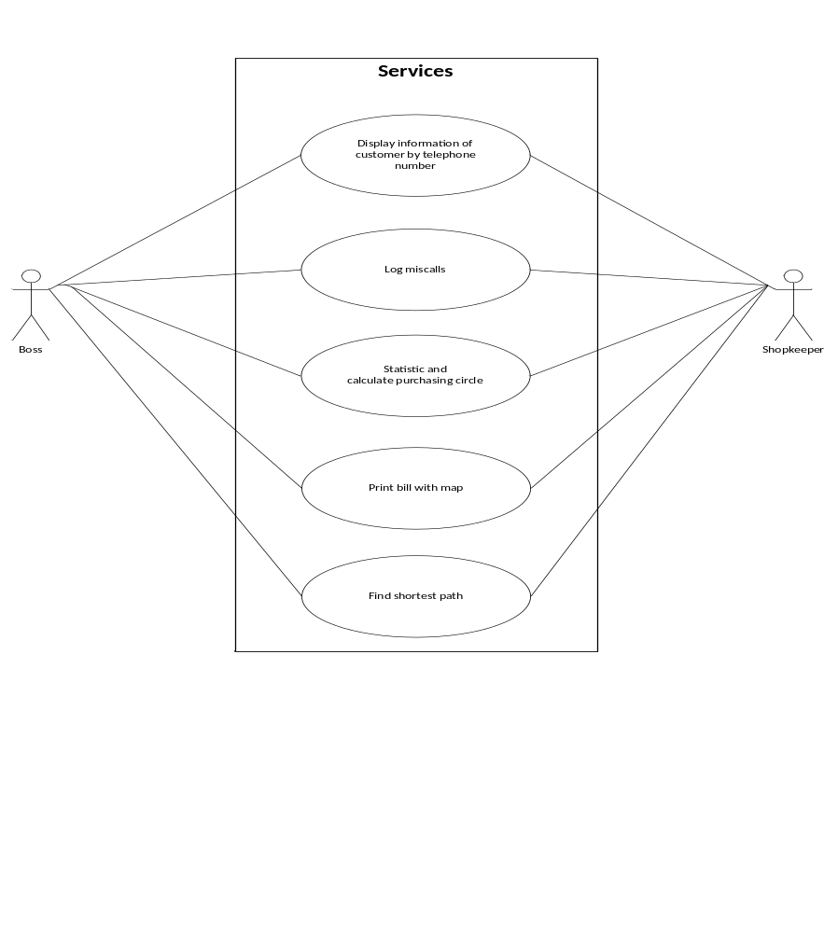
Figure 1: Services feature use case

      - Use case description

Use case 001: View information of call come in

USE CASE 1 SPECIFICATION

Use-case No. | UC001 | Use-case Version |  | 1.0
Use-case Name | View information of call come in
Author | Le The Dai Duong
Date | 02/06/2012 | Priority | Normal
Actor:
Managers
Staffs
Summary:
User can view information of customer who is calling in shop
Triggers
Customer call in the shop
Preconditions:
N/A
Post Conditions:
Information screen will be displayed
Staff can change information of customer
Main Success Scenario:
Customer call in
Information screen will be displayed on new screen
Staff can change information of customer
In main screen, list of call is updated
In main screen, new call will have notification
Press “Sửa” button on the information screen to change information
Press “Thoát” button on the information screen to exit
Press “Thoát” button, notification on main screen disappear
Alternative Scenario:
N/A
Exceptions:
Information of customer is not saved into database
Relationships:
Insert, update customer information
Business Rules:
Information of customer will be displayed within 3 seconds

Use case 002: Log miscall

USE CASE 2 SPECIFICATION

Use-case No. | UC002 | Use-case Version |  | 1.0
Use-case Name | Log miscall
Author | Le The Dai Duong
Date | 02/06/2012 | Priority | Normal
Actor:
Managers
Staffs
Summary:
System will log miscall automatically
Triggers
Customer call in the shop
Preconditions:
Nobody answer the call come in
Post Conditions:
Information of the call will be saved
Notification will be appear
Main Success Scenario:
Customer call in
Nobody answer the call
Information screen will be displayed on new screen
In main screen, list of call is updated
In main screen, miscall will have notification
Press “Sửa” button on the information screen to change information
Press “Thoát” button on the information screen to exit
Press “Thoát” button, notification on main screen disappear
Alternative Scenario:
N/A
Exceptions:
N/A
Relationships:
N/A
Business Rules:
Information of customer will be logged within 3 seconds

Use case 003: Calculate purchasing circle

USE CASE 3 SPECIFICATION

Use-case No. | UC003 | Use-case Version |  | 1.0
Use-case Name | Calculate purchasing circle
Author | Le The Dai Duong
Date | 02/06/2012 | Priority | Normal
Actor:
Managers
Staffs
Summary:
User can calculate purchasing circle of customer
Triggers
Customer must be buy product 3 times at least
Preconditions:
N/A
Post Conditions:
List of potential customer will be displayed
Main Success Scenario:
First start system on the day
System will calculate purchasing circle automatically
All potential customer information will be displayed
Alternative Scenario:
Click “Chăm sóc KH” in menu
Choose “Khách hàng tiềm năng”
System will calculate purchasing circle automatically
All potential customer information will be displayed
Exceptions:
N/A
Relationships:
N/A
Business Rules:
Information of customer who could buy products in next 3 days will be displayed

Use case 004: Find shortest path

USE CASE 4 SPECIFICATION

Use-case No. | UC004 | Use-case Version |  | 1.0
Use-case Name | Find shortest path
Author | Le The Dai Duong
Date | 02/06/2012 | Priority | Normal
Actor:
Managers
Staffs
Summary:
User can find shortest path to address of customer
Triggers
Address must be provided by customer
Preconditions:
System must be connecting with internet.
Post Conditions:
Shortest path from shop to address of customer will be showed in map
Image of map and shortest will saved in database
Main Success Scenario:
Customer call in
Enter or change address
System automatically find shortest path to address of customer
Alternative Scenario:
View information of customer
Change address
System automatically find shortest path to address of customer
Exceptions:
N/A
Relationships:
N/A
Business Rules:
N/A

Use case 005: Print bill with map

USE CASE 5 SPECIFICATION

Use-case No. | UC005 | Use-case Version |  | 1.0
Use-case Name | Print bill with map
Author | Le The Dai Duong
Date | 02/06/2012 | Priority | Normal
Actor:
Managers
Staffs
Summary:
User can print bill with map to address of customer
Triggers
Address must be provided by customer
Preconditions:
N/A
Post Conditions:
Bill with map of customer will be printed though printer
Main Success Scenario:
Customer call in
Enter or change address
Enter information of customer and product
Click “In” button
Click “Ok”
Alternative Scenario:
Choose “In Hóa đơn” in menu
Chose or input customer
Enter address
Enter information of customer and product
Click “In” button
Click “Ok”
Exceptions:
N/A
Relationships:
N/A
Business Rules:
N/A

    - Management feature
      - Use case diagram
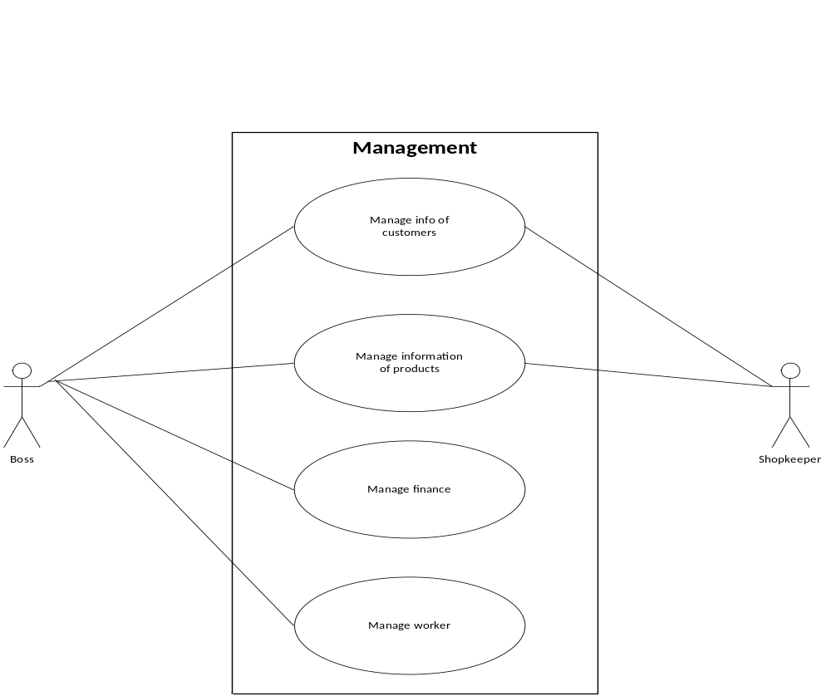
Figure 2: Management feature use case

      - Use case description

Use case 006: Insert new customer

USE CASE 6 SPECIFICATION

Use-case No. | UC006 | Use-case Version |  | 1.0
Use-case Name | Insert new customer
Author | Le The Dai Duong
Date | 02/06/2012 | Priority | Normal
Actor:
Staffs
Managers
Summary:
User can insert new information of customer into database
Triggers
New phone number call in
Preconditions:
N/A
Post Conditions:
New information will be saved into database
New information will be displayed
Main Success Scenario:
New call comes in
Insert screen will be displayed
Enter information of customer
Press “Ok” button
Alternative Scenario:
User choose “thêm khách hàng” in menu
User must enter phone number
Enter information of customer
Press “OK” button
Exceptions:
Phone number existed in database
Information of customer is not saved into database
Relationships:
N/A
Business Rules:
N/A

Use case 007: Update customer information

USE CASE 7 SPECIFICATION

Use-case No. | UC007 | Use-case Version |  | 1.0
Use-case Name | Update customer information
Author | Le The Dai Duong
Date | 02/06/2012 | Priority | Normal
Actor:
Staffs
Managers
Summary:
User can update information of customer into database
Triggers
Some information of customer changed
Preconditions:
Information of customer must be displayed
Post Conditions:
New information will be saved into database
New information will be displayed
Main Success Scenario:
Customer calls in
Notification screen will be displayed
Press “Sửa” button
Change information of customer
Press “Ok” button
Alternative Scenario:
View information of customer
Choose one customer
Press “Sửa” button
Change information of customer
Press “OK” button
Exceptions:
Phone number existed in database
Information of customer is not saved into database
Relationships:
N/A
Business Rules:
N/A

Use case 008: Delete customer information

USE CASE 8 SPECIFICATION

Use-case No. | UC008 | Use-case Version |  | 1.0
Use-case Name | Delete customer information
Author | Le The Dai Duong
Date | 02/06/2012 | Priority | Normal
Actor:
Staffs
Managers
Summary:
User can delete information of customer from database
Triggers
Some customers is no longer necessary
Preconditions:
Information of customer must be displayed
Post Conditions:
New information will be delete from database
Customer table will be displayed
Main Success Scenario:
View information of customer
Choose one customer
Press “Xóa” button
Press “OK” button
Alternative Scenario:
N/A
Exceptions:
Change in database error
Relationships:
N/A
Business Rules:
N/A

Use case 009: Search customer information

USE CASE 9 SPECIFICATION

Use-case No. | UC009 | Use-case Version |  | 1.0
Use-case Name | Search customer information
Author | Le The Dai Duong
Date | 02/06/2012 | Priority | Normal
Actor:
Staffs
Managers
Summary:
User can search information of customer
Triggers
User must choose customer category
Preconditions:
List of categories must be displayed to users
Post Conditions:
List of specific customer will be displayed
Main Success Scenario:
Choose customer category
Enter key word in text search
Press “Tìm kiếm” button
Alternative Scenario:
N/A
Exceptions:
N/A
Relationships:
N/A
Business Rules:
N/A

Use case 010: Enter security password successful

USE CASE 10 SPECIFICATION

Use-case No. | UC010 | Use-case Version |  | 1.0
Use-case Name | Enter security password successful
Author | Le The Dai Duong
Date | 02/06/2012 | Priority | Normal
Actor:
Managers
Summary:
System asked security password to user
Triggers
User want to insert or update information of staff, products
Preconditions:
N/A
Post Conditions:
User can change information in database
Main Success Scenario:
Security password screen display
User can press “Thoát” button to exit
Enter right password
Press “OK” button
Password screen disappear
Information can be changed.
Alternative Scenario:
N/A
Exceptions:
N/A
Relationships:
Insert, update, delete staff
Insert, update, delete product
Business Rules:
Password discriminate between upper and lower character
Password should include specific, upper and number character

Use case 011: Enter wrong security password

USE CASE 11 SPECIFICATION

Use-case No. | UC011 | Use-case Version |  | 1.0
Use-case Name | Enter wrong security password
Author | Le The Dai Duong
Date | 02/06/2012 | Priority | Normal
Actor:
Managers
Summary:
System asked security password to user
Triggers
User want to insert or update information of staff, products
Preconditions:
N/A
Post Conditions:
Security password screen will be remained
Main Success Scenario:
Security password screen display
Can be press “Thoát” button to exit
Enter wrong password
Press “OK” button
Fail massage will be displayed
Security password screen will be remained
Alternative Scenario:
N/A
Exceptions:
N/A
Relationships:
Insert, update, delete staff
Insert, update, delete product
Business Rules:
Password discriminate between upper and lower character
Password should include specific, upper and number character

Use case 012: Change security password

USE CASE 12 SPECIFICATION

Use-case No. | UC012 | Use-case Version |  | 1.0
Use-case Name | Change security password
Author | Le The Dai Duong
Date | 02/06/2012 | Priority | Normal
Actor:
Managers
Summary:
User change security password
Triggers
N/A
Preconditions:
“Bảo mật” menu must be chosen
Post Conditions:
Security password will be changed
Main Success Scenario:
Click “Bảo mật” menu
Chose “Thay đổi password”
Change security password screen is displayed
Can be press “Thoát” button to exit
Enter right password in “Password” text
Enter new password in “Nhập Password” text
Retype new password in “Kiểm tra Password”
Press “OK” button
Success massage will be displayed
Security password will be changed
Alternative Scenario:
N/A
Exceptions:
New password is same last password
Relationships:
Insert, update, delete staff
Insert, update, delete product
Business Rules:
Password discriminate between upper and lower character
Password should include specific, upper and number character

Use case 013: Insert new product

USE CASE 13 SPECIFICATION

Use-case No. | UC013 | Use-case Version |  | 1.0
Use-case Name | Insert new product
Author | Le The Dai Duong
Date | 02/06/2012 | Priority | Normal
Actor:
Managers
Summary:
User can insert new product into database
Triggers
New product is in category
Preconditions:
N/A
Post Conditions:
New information will be saved into database
New information will be displayed
Main Success Scenario:
User choose “thêm sản phẩm” in menu
Enter security password
Enter information of customer
Press “OK” button
Alternative Scenario:
N/A
Exceptions:
Information of product is not saved into database
Relationships:
Security password
Business Rules:
N/A

Use case 014: Update product information

USE CASE 14 SPECIFICATION

Use-case No. | UC014 | Use-case Version |  | 1.0
Use-case Name | Update product information
Author | Le The Dai Duong
Date | 02/06/2012 | Priority | Normal
Actor:
Managers
Summary:
User can update information of product into database
Triggers
Some information of product changed
Preconditions:
Information of product must be displayed
Post Conditions:
New information will be saved into database
New information will be displayed
Main Success Scenario:
View information of product
Choose one product
Press “Sửa” button
Enter security password
Change information of product
Press “OK” button
Alternative Scenario:
N/A
Exceptions:
Information of products is not saved into database
Relationships:
Security password
Business Rules:
N/A

Use case 015: Delete product information

USE CASE 15 SPECIFICATION

Use-case No. | UC015 | Use-case Version |  | 1.0
Use-case Name | Delete product information
Author | Le The Dai Duong
Date | 02/06/2012 | Priority | Normal
Actor:
Managers
Summary:
User can delete product from database
Triggers
Some product is no longer necessary
Preconditions:
Information of products must be displayed
Post Conditions:
New information will be delete from database
Product table will be displayed
Main Success Scenario:
View information of products
Choose one product
Press “Xóa” button
Enter security password
Press “OK” button
Alternative Scenario:
N/A
Exceptions:
Change in database error
Relationships:
Security password
Business Rules:
N/A

Use case 016: Search product information

USE CASE 16 SPECIFICATION

Use-case No. | UC016 | Use-case Version |  | 1.0
Use-case Name | Search product information
Author | Le The Dai Duong
Date | 02/06/2012 | Priority | Normal
Actor:
Staffs
Managers
Summary:
User can search information of product
Triggers
User must choose product category
Preconditions:
List of categories must be displayed to users
Post Conditions:
List of specific product will be displayed
Main Success Scenario:
Choose product category
Enter key word in text search
Press “Tìm kiếm” button
Alternative Scenario:
N/A
Exceptions:
N/A
Relationships:
N/A
Business Rules:
N/A

Use case 017: Manage sales

USE CASE 17 SPECIFICATION

Use-case No. | UC017 | Use-case Version |  | 1.0
Use-case Name | Manage sales
Author | Le The Dai Duong
Date | 02/06/2012 | Priority | Normal
Actor:
Managers
Staffs
Summary:
User can statistic turnover, profit, debt and product buy month or quarter
Triggers
Report sales
Preconditions:
List of moth must be displayed to user
Post Conditions:
Information of business activities will be displayed
Main Success Scenario:
Click “Thống kê” in menu
Choose categories
Choose day, month or quarter when user need to statistic
System automatically statistic information
Click “In” button to print report
Click “Ok” to exit
Alternative Scenario:
N/A
Exceptions:
N/A
Relationships:
Manager products
Business Rules:
Statistic will perform within 5 seconds

Use case 018: Manage promotion

USE CASE 18 SPECIFICATION

Use-case No. | UC018 | Use-case Version |  | 1.0
Use-case Name | Manage promotion
Author | Le The Dai Duong
Date | 02/06/2012 | Priority | Normal
Actor:
Managers
Summary:
User can manage promotion program for customer
Triggers
Customer service
Preconditions:
List of moth must be displayed to user
Post Conditions:
Information of promotion program will effect on price and profit of products
Main Success Scenario:
Click “Chăm sóc KH” in menu
Choose categories- create, delete or view promotion program
Enter security password
+)Create promotion
Enter information of promotion program
Press “OK” button
+) Delete promotion
Choose promotion program
Press “Xóa” button
Press “OK”
+) View
Double click on promotion which user want to view
Information of program will be displayed
Press “OK” to exit
Alternative Scenario:
N/A
Exceptions:
N/A
Relationships:
Manage sale, create bill
Business Rules:
User must enter security password
Promotion program will effect in price of product and profit

Use case 019: Insert new staff

USE CASE 19 SPECIFICATION

Use-case No. | UC019 | Use-case Version |  | 1.0
Use-case Name | Insert new staff
Author | Le The Dai Duong
Date | 02/06/2012 | Priority | Normal
Actor:
Managers
Summary:
User can insert new staff into database
Triggers
New staff is in shop
Preconditions:
N/A
Post Conditions:
New information will be saved into database
New information will be displayed
Main Success Scenario:
User choose “thêm nhân viên” in menu
Enter security password
Enter information of staff
Press “OK” button
Alternative Scenario:
N/A
Exceptions:
Information of staff is not saved into database
Relationships:
Security password
Business Rules:
N/A

Use case 020: Update staff information

USE CASE 20 SPECIFICATION

Use-case No. | UC020 | Use-case Version |  | 1.0
Use-case Name | Update staff information
Author | Le The Dai Duong
Date | 02/06/2012 | Priority | Normal
Actor:
Managers
Summary:
User can update information of staff into database
Triggers
Some information of staff changed
Preconditions:
Information of staff must be displayed
Post Conditions:
New information will be saved into database
New information will be displayed
Main Success Scenario:
View information of staff
Choose one staff
Press “Sửa” button
Enter security password
Change information of staff
Press “OK” button
Alternative Scenario:
N/A
Exceptions:
Information of staffs is not saved into database
Relationships:
Security password
Business Rules:
N/A

Use case 021: Delete staff information

USE CASE 21 SPECIFICATION

Use-case No. | UC021 | Use-case Version |  | 1.0
Use-case Name | Delete staff information
Author | Le The Dai Duong
Date | 02/06/2012 | Priority | Normal
Actor:
Managers
Summary:
User can delete information of staff from database
Triggers
Some staff is no longer necessary
Preconditions:
Information of staff must be displayed
Post Conditions:
New information will be delete from database
Product table will be displayed
Main Success Scenario:
View information of staffs
Choose one staff
Press “Xóa” button
Enter security password
Press “OK” button
Alternative Scenario:
N/A
Exceptions:
Change in database error
Relationships:
Security password
Business Rules:
N/A

Use case 022: Search staff information

USE CASE 22 SPECIFICATION

Use-case No. | UC022 | Use-case Version |  | 1.0
Use-case Name | Search staff information
Author | Le The Dai Duong
Date | 02/06/2012 | Priority | Normal
Actor:
Managers
Summary:
User can search information of staff
Triggers
User must choose “Quản lý” menu
Preconditions:
User must be search by key word
Post Conditions:
List of specific product will be displayed
Main Success Scenario:
Choose “Quản lý” category
Enter security password
Enter key word in text search
Press “Tìm kiếm” button
Alternative Scenario:
N/A
Exceptions:
N/A
Relationships:
N/A
Business Rules:
N/A

External Interface Requirements
    - User Interfaces
Because system has 2 parts hardware and software so:
Hardware:
Small, tiny and easy to move
Unshakeable, reliable
Software:
Big icon
Distance between button must ensues interact correctly
Easy to view
Easy to identify functions
Fit full screen
    - Hardware Interfaces
CPU: Intel® Pentium® 4 2.4 GHz or better supported
RAM: 512 MB or better supported
Hard Drive: 200MB of free space or more
Board
Mouse
USB cable
Telephone display phone number
Internet
    - Software Interfaces
OS: Windows XP with Service Pack 3(SP3) (32-bit), Windows Vista with SP1, Windows 7 operating system
C#.Net framework 2.0
SQL Server 2005 express
Drive TUSB3410
    - Communications Protocol
GSS system uses RS232 RS-232 serial communication protocol, a standard protocol used in asynchronous serial communication. It is the primary protocol used over modem lines. It is the protocol used by the MicroStamp11 when it communicates with a host PC. These components are the UART, the serial channel, and the interface logic. An interface chip known as the universal asynchronous receiver/transmitter or UART is used to implement serial data transmission. The UART sits between the host computer and the serial channel. The serial channel is the collection of wires over which the bits are transmitted. The output from the UART is a standard TTL/CMOS logic level of 0 or 5 volts. In order to improve bandwidth, remove noise, and increase range, this TTL logical level is converted to an RS-232 logic level of or volts before being sent out on the serial channel. This conversion is done by the interface logic shown in figure 3. In GSS system the interface logic is implemented by the comm stamp.
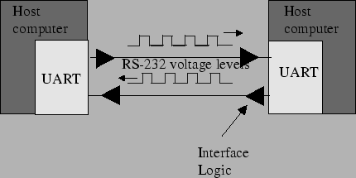
Figure 3: Asynchronous (RS-232) serial link
A frame is a complete and nonvisible packet of bits. A frame includes both information (e.g., data and characters) and overhead (e.g., start bit, error checking and stop bits). In asynchronous serial protocols such as RS-232, the frame consists of one start bit, seven or eight data bits, parity bits, and stop bits. A timing diagram for an RS-232 frame consisting of one start bit, 7 data bits, one parity bits and two stop bits is shown in figure 4.
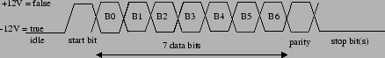
Figure 4: RS-232 Frame (1 start bit, 7 data bits, 1 parity bits, and 2 stop bits)
Most of the bits in a frame are self-explanatory. The start bit is used to signal the beginning of a frame and the stop bit is used to signal the end of a frame. The only bit that probably needs a bit of explanation is the parity bit. Parity is used to detect transmission errors. For even parity checking, the number of 1's in the data plus the parity bit must equal an even number. For odd parity, this sum must be an odd number. Parity bits are used to detect errors in transmitted data. Before sending out a frame, the transmitter sets the parity bit so that the frame has either even or odd parity. The receiver and transmitter have already agreed upon which type of parity check (even or odd) is being used. When the frame is received, then the receiver checks the parity of the received frame. If the parity is wrong, then the receiver knows an error occurred in transmission and the receiver can request that the transmitter re-send the frame.
In cases where the probability of error is extremely small, then it is customary to ignore the parity bit. For communication between the MicroStamp11 and the host computer, this is usually the case and so we ignore the parity bit.
The bit time is the basic unit of time used in serial communication. It is the time between each bit. The transmitter outputs a bit, waits one bit time and then outputs the next bit. The start bit is used to synchronize the transmitter and receiver. After the receiver senses the true-false transition in the start bit, it waits one half bit time and then starts reading the serial line once every bit time after that. The baud rate is the total number of bits (information, overhead, and idle) per time that is transmitted over the serial link. So we can compute the baud rate as the reciprocal of the bit time.

Entity relationship diagram
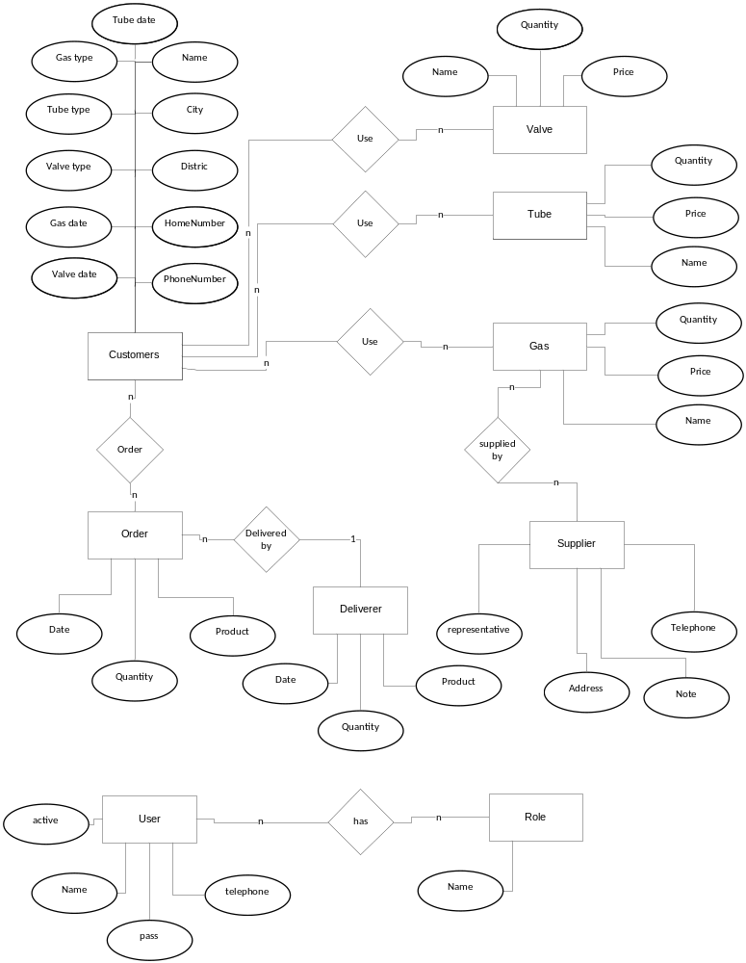
Figure 5: ERD

